AMR Sentinel Dashboard – Early Warnings (Zone-1)
Purpose
The Early Warnings section of the AMR Sentinel dashboard is designed to proactively identify emerging antimicrobial resistance risks before they cause clinical trial failures or drug pipeline disruptions. This section continuously monitors resistance data and highlights abnormal patterns that require immediate attention.

Overall Message Conveyed
The Early Warnings dashboard communicates that antimicrobial resistance is rising in specific regions, time periods, and trial settings, and that these changes are detectable early through systematic surveillance rather than post-failure analysis.
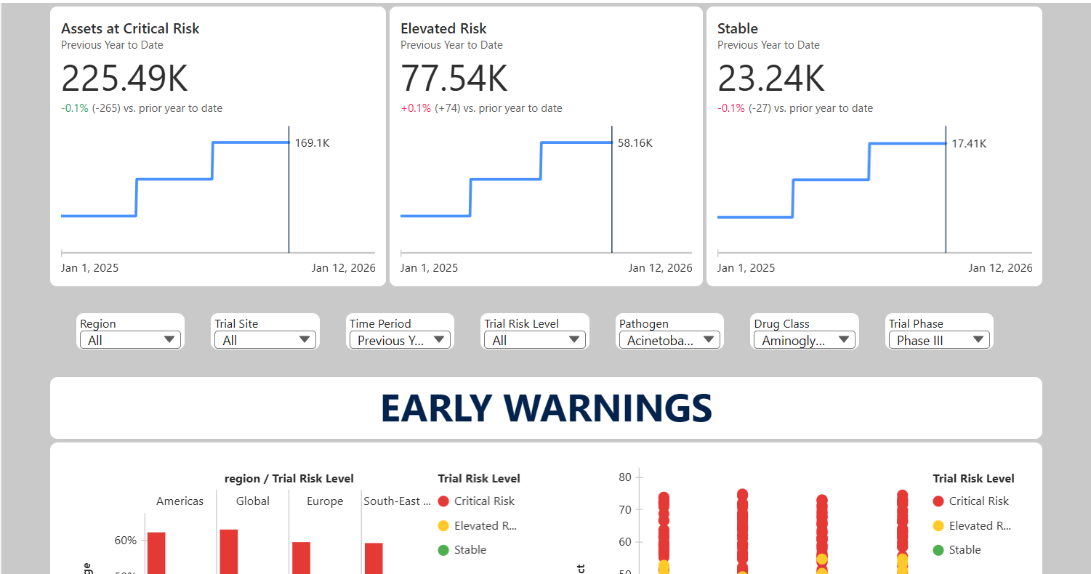
KPI Metrics – Risk Summary Cards
Assets at Critical Risk
Shows the total number of assets currently classified as Critical Risk and how this number has changed compared to the previous year.
Assets at Elevated Risk
Displays assets showing moderate resistance that could escalate if left unmonitored.
Assets at Stable Risk
Represents assets currently showing low resistance levels and lower immediate concern.
Key message:
Resistance risk is quantifiable, trackable over time, and trending, not anecdotal or static.
How These Elements Work Together
- Charts identify where and when resistance is emerging
- KPIs confirm how widespread the risk is
- Filters allow users to drill down for deeper investigation
Together, these elements form an early-warning system that detects resistance threats before they translate into financial or clinical failure.

Role of Filters
The filters at the top of the dashboard (Region, Trial Site, Time Period, Trial Risk Level, Pathogen, Drug Class, and Trial Phase) allow users to:
- Narrow the analysis to specific trials or regions
- Focus on critical clinical phases such as Phase III
- Investigate resistance patterns for particular pathogens or drug classes
This ensures the dashboard supports real-world investigative and decision-making workflows.
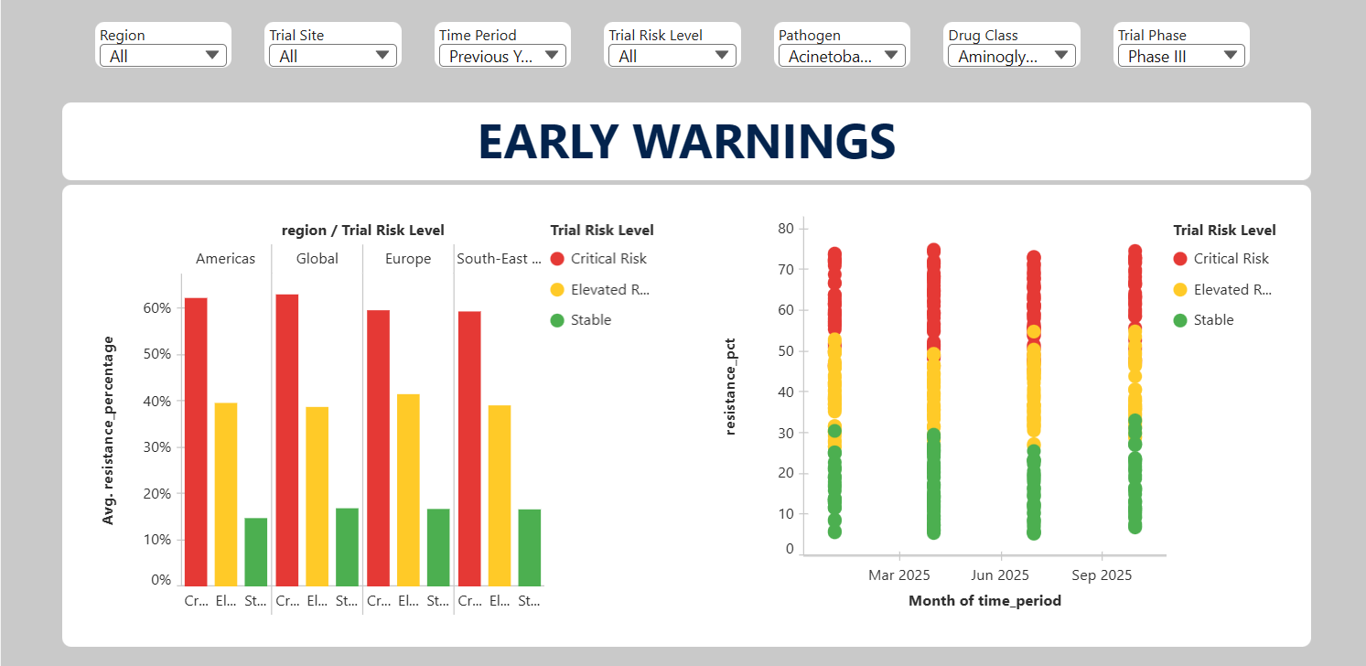
Explanation of Visualizations
1. Region vs Trial Risk Level Chart
This chart displays the average resistance percentage across different regions, grouped by Trial Risk Level (Critical, Elevated, Stable).
What it explains:
- Certain regions consistently show higher resistance levels
- Regions classified under Critical Risk exhibit significantly higher resistance than Stable regions
Key message:
Geographic location plays a major role in resistance severity, and some regions pose higher structural risk to clinical trials.

2. Resistance Trend Over Time Chart
This visualization shows resistance percentage over time, plotted monthly and color-coded by Trial Risk Level.
What it explains:
- Resistance does not increase suddenly; it rises gradually
- Critical risk points cluster at higher resistance values
- Emerging spikes are visible early, before long-term averages change
Key message:
Antimicrobial resistance trends can be detected early through time-based monitoring, enabling proactive intervention.
AMR Sentinel Dashboard – Impact Assessment (Zone-2)
Purpose
The Impact Assessment section of the AMR Sentinel dashboard is designed to translate early antimicrobial resistance signals into measurable scientific and business impact. While the Early Warnings section identifies where resistance is emerging, this section explains why those signals matter and which assets are most at risk.

Overall Message Conveyed
The Impact Assessment dashboard communicates that emerging antimicrobial resistance directly threatens specific clinical trials, drug classes, pathogens, and regions, and that this threat can be quantified, prioritized, and compared.
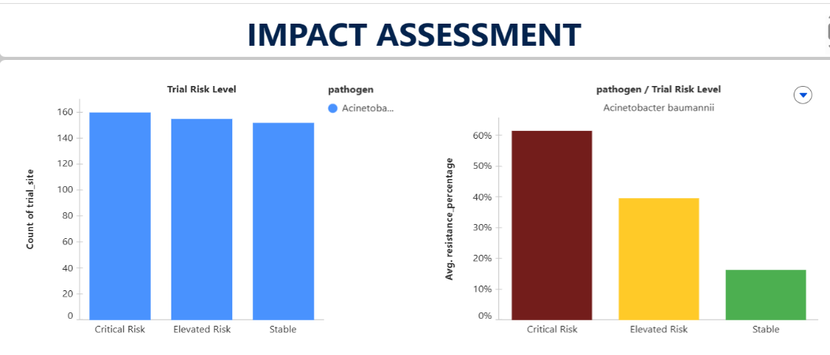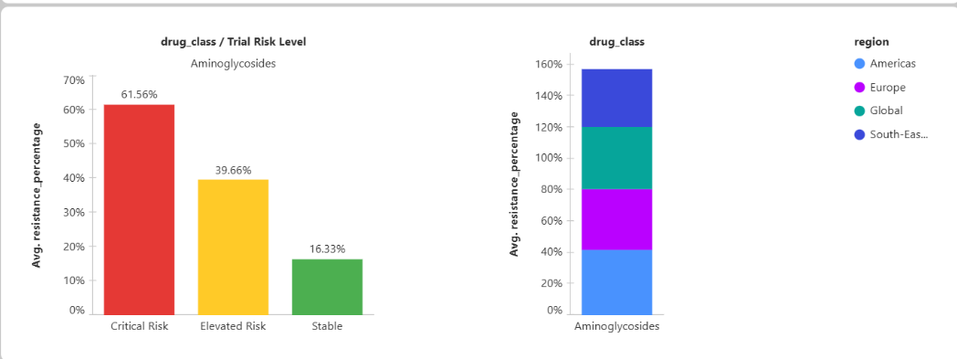
Explanation of Visualizations
1. Trial Risk Level vs Count of Trial Sites
This chart shows the number of trial sites categorized under each Trial Risk Level (Critical, Elevated, Stable).
What it explains:
- How widespread resistance risk is across trials
- Whether risk is limited to a few sites or affects a large portion of the pipeline
Key message:
Resistance risk is not isolated; it affects a significant number of trial sites and therefore represents a systemic pipeline concern.

2. Pathogen vs Trial Risk Level (Average Resistance Percentage)
This chart displays the average resistance percentage for a selected pathogen across different Trial Risk Levels.
What it explains:
- Biological severity of resistance for a specific pathogen
- Clear separation between Critical, Elevated, and Stable risk categories
Key message:
Certain pathogens show high resistance levels that directly drive trial risk, validating the scientific basis of the risk classification.

3. Drug Class vs Trial Risk Level (Average Resistance Percentage)
This visualization compares average resistance levels for a specific drug class across Trial Risk Levels.
What it explains:
- Which antibiotic classes are losing effectiveness
- How resistance severity escalates from Stable to Critical risk
Key message:
Specific drug classes are more vulnerable to resistance, posing a direct threat to the pharmaceutical portfolio.
4. Drug Class vs Region (Stacked Resistance Distribution)
This chart shows how resistance for a drug class is distributed across regions.
What it explains:
- Geographic drivers of resistance within the same drug class
- Regions that contribute most to overall resistance burden
Key message:
Resistance impact is regionally uneven, enabling informed decisions about trial site selection or geographic risk mitigation.

How These Elements Work Together
- Trial counts show scale of exposure
- Pathogen analysis explains biological drivers
- Drug class analysis reveals portfolio vulnerability
- Regional breakdown identifies geographic sources of risk
Together, these visuals convert raw resistance data into clear, comparable impact metrics.

AMR Sentinel Dashboard – Prescriptive Action (Zone-3)
Purpose
The Prescriptive Action section of the AMR Sentinel dashboard is designed to convert antimicrobial resistance insights into clear, executable decisions. While the previous sections identify resistance patterns and assess their impact, this section answers the most critical operational question: “What should be done now?”

Overall Message Conveyed
The Prescriptive Action dashboard communicates that each clinical trial site has a defined risk-driven recommendation, enabling immediate mitigation steps to protect ongoing trials and the pharmaceutical pipeline.
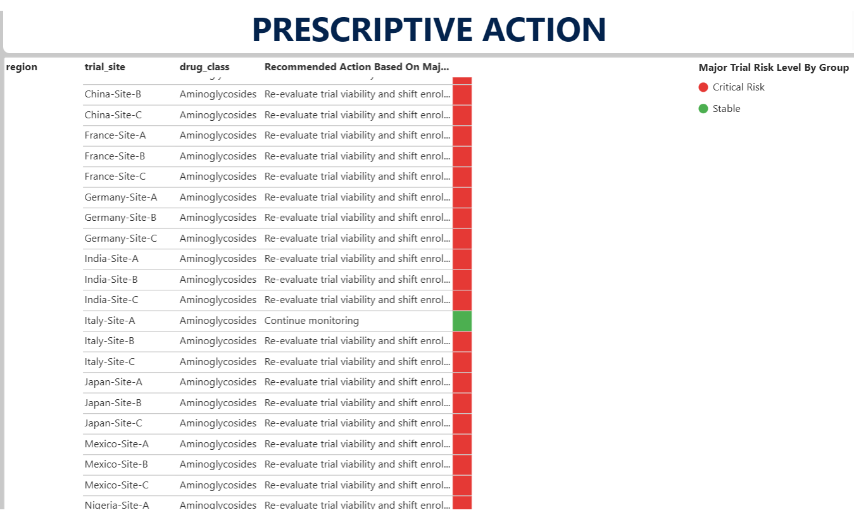
Explanation of the Prescriptive Action Table
1. Region
Indicates the geographic location of the clinical trial site.
Purpose:
Helps teams understand where action is required geographically, enabling regional coordination and resource planning.

2. Trial Site
Lists individual clinical trial sites affected by antimicrobial resistance risk.
Purpose:
Provides site-level visibility, allowing operational teams to act without additional investigation.

3. Drug Class
Displays the antibiotic class used in the trial at each site.
Purpose:
Connects resistance risk to specific therapeutic assets, ensuring actions are aligned with the correct drug portfolio.

4. Recommended Action Based on Major Trial Risk Level
Shows a clear, pre-defined recommendation generated from the trial’s risk classification.
Examples of actions include:
- Re-evaluate trial viability and shift enrollment to lower-risk regions
- Continue monitoring under standard surveillance
Purpose:
Eliminates ambiguity by providing direct guidance, reducing decision delays.

5. Major Trial Risk Level by Group (Color Indicator)
Uses color coding to visually represent risk severity:
- Red – Critical Risk
- Green – Stable
Purpose:
Allows stakeholders to instantly prioritize which sites require immediate attention.

How This Section Supports Decision-Making
- Converts analytical insights into operational instructions
- Enables rapid escalation for critical-risk trials
- Supports consistent, risk-aligned decision-making across teams

